# Data Flow Diagrams:

Project Design Phase-II Data Flow Diagram &User Stories

|  |  |
| --- | --- |
| Date | 17 October 2022 |
| Team ID | PNT2022TMID28212 |
| Project Name | Early Detection of Chronic Kidney Disease  using Machine Learning |
| Maximum Marks | 4 Marks |

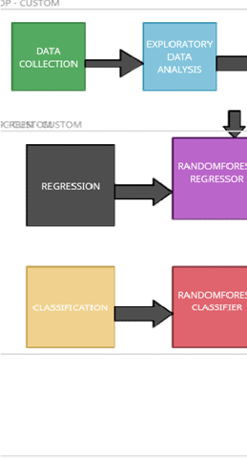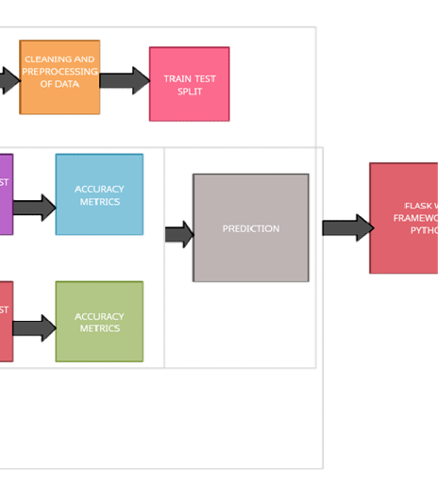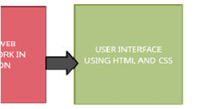

Data Flow of Chronic Disease Prediction

1. Medical data of patients is collected from kaggle.
2. Exploratory data analysis done on the input dataset
3. Then removal of null vaues, duplicates and outliers.
4. Then the dependent and independent variable is defined
5. Train test split is done
6. Both classification and regression model is built
7. For Classification, the model is trained with RandomForestClassifier and tested with test dataset
8. For Regression, the model is trained with RandomForestRegressor and tested with test dataset
9. Then the model is fitted with front end which is developed using HTML,CSS with the help of Python Flask Web Framework
10. Finally the output will be predicted for the user input data

# User Stories

Use the below template to list all the user stories for the product.

|  |  |  |  |  |  |  |
| --- | --- | --- | --- | --- | --- | --- |
| **User Type** | **Functional**  **Requirement (Epic)** | **User Story Number** | **User Story / Task** | **Acceptance criteria** | **Priority** | **Release** |
| Customer (Web user) | Registration | USN-1 | As a user, I can register for the application by  entering my email, password, and confirming my password. | I can access my account / dashboard | High | Sprint-1 |
|  | Verification | USN-2 | As a user, I will receive confirmation email  once I have registered for the application | I can receive confirmation  email & click confirm | High | Sprint-1 |
|  | Login | USN-3 | As a user, I can log into the application by  entering email & password | Check whether password  and email is correct | High | Sprint-1 |
|  | Dashboard | USN-4 | If the email id and password is correct, the user can log in to application otherwise it  shows ‘incorrect password or Id’. | View the dashboard of user who is log in | High | Sprint-1 |
| Customer Care Executive | Help | USN-5 | If the user faces any issues, he/she an report it to our mail id. | Report option will be available in web app | High | Sprint-2 |
| Administrator | Verification | USN-6 | Administrator also has unique Id and  password to login. He has additional users to organize the users of this web app | Check whether password and email is correct | High | Sprint-3 |
|  | | | | | | |